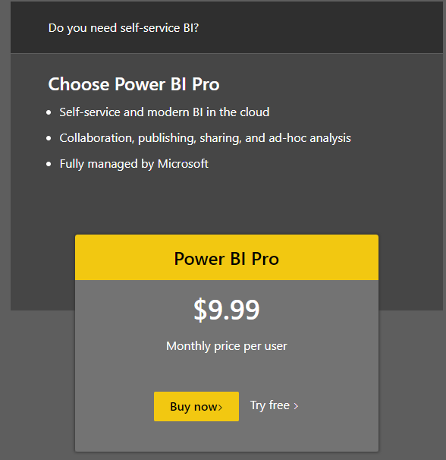

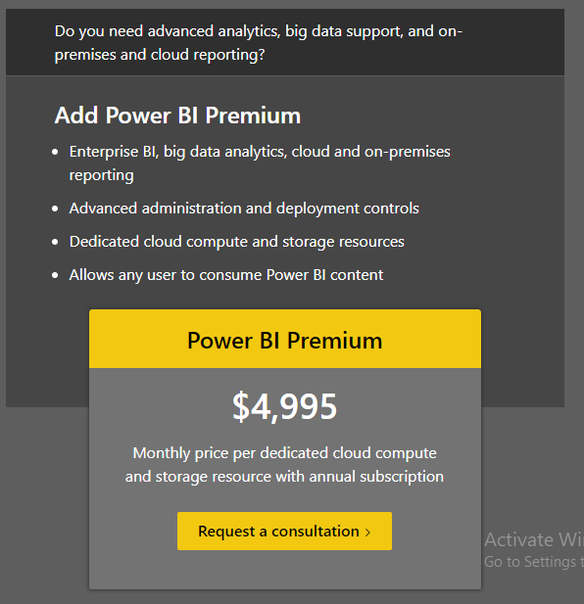

Power Bi Desktop:

Connect to your data, wherever it is - Access data from hundreds of supported on-premises and cloud-based sources, such as Dynamics 365, Salesforce, Azure SQL DB, Excel, and SharePoint. Ensure it’s always up to date with automated, incremental refreshes. Power BI Desktop enables you to develop deep, actionable insights for a broad range of scenarios.

Prep and model your data with ease - Save time and make data prep easier with data modeling tools. Reclaim hours in your day using the self-service Power Query experience familiar to millions of Excel users. Ingest, transform, integrate, and enrich data in Power BI.

Provide advanced analytics with the familiarity of Office -Dig deeper into data and find patterns you may have otherwise missed that lead to actionable insights. Use features like quick measures, grouping, forecasting, and clustering. Give advanced users full control over their model using powerful DAX formula language. If you’re familiar with Office, you’ll feel at home in Power BI.

Deepen your data insights with AI-driven augmented analytics - Explore your data, automatically find patterns, understand what your data means, and predict future outcomes to drive business results. The new AI capabilities—pioneered in Azure and now available in Power BI—require no code, enabling all of your Power BI users to discover hidden, actionable insights and drive more strategic business outcomes.

Create interactive reports customized for your business - Create stunning reports with interactive data visualizations. Tell your data story using a drag-and-drop canvas and hundreds of modern data visuals from Microsoft and partners—or create your own, using the Power BI open source custom visuals framework. Design your report with theming, formatting, and layout tools.

Author for everyone, anywhere -Get visual analytics to the people who need it. Create mobile-optimized reports for viewers to consume on the go. Publish from Power BI Desktop to the cloud or on-premises. Embed reports created in Power BI Desktop into existing apps or websites.

